Software Requirement Specification (SRS)
Speed-Based Media Volume Control System

1. Introduction
1.1 Purpose
The system aims to improve driver comfort and safety by reducing the need for manual volume adjustments during driving. The project is to develop a system that automatically adjusts the media volume in a vehicle based on the vehicle’s speed.

1.2 Scope
The system monitors vehicle speed and dynamically changes the media volume level.
Included Features-
- Real-time vehicle speed monitoring
- Automatic media volume adjustment
- Smooth volume transition
- Manual volume override
- Basic UI for speed and volume display
- Logging and debugging support

2. Overall Description
2.1 Product Perspective
The system works as middleware between the vehicle speed signal and the audio management system. It receives vehicle speed data and adjusts the media volume accordingly using predefined rules.

2.2 Product Functions
The system shall:
- Read vehicle speed continuously
- Calculating required volume level
- Increase volume at higher speeds
- Decrease volume at lower speeds
- Avoid sudden volume changes
- Respect manual user adjustments
- Display current speed and volume

2.3 Operating Environment
- Vehicle infotainment system
- Android/Linux-based automotive platform
- Audio Manager APIs
- Vehicle HAL / CAN Interface

3. Functional Requirements
FR-1: Vehicle Speed Monitoring
The system shall continuously receive vehicle speed data from the Vehicle HAL/CAN interface.
Input
- Vehicle speed signal
Output
- Updated speed value

FR-2: Automatic Volume Adjustment
The system shall automatically adjust media volume based on vehicle speed.
Example Logic
Speed Range | Volume Level
0–20 km/h | Low
21–50 km/h | Medium
Above 50 km/h | High

FR-3: Smooth Volume Transition
The system shall gradually adjust volume to avoid sudden changes.

FR-4: Manual Override
If the driver manually changes volume:
- Automatic adjustment shall pause temporarily
- User preference shall be respected

FR-5: Volume Threshold Protection
The system shall:
- Maintain minimum volume limit
- Maintain maximum volume limit

FR-6: UI Display
The UI shall display:
- Current vehicle speed
- Current media volume level

FR-7: Logging
The system shall log:
- Speed changes
- Volume adjustments
- Manual overrides
- System errors

4. Non-Functional Requirements
4.1 Performance
- Volume adjustment response time shall be less than 2 seconds.
- System shall support real-time speed updates.

4.2 Reliability
- System shall function continuously without crashes.
- Invalid speed values shall be handled safely.

4.3 Usability
- Volume changes should feel smooth and non-intrusive.
- UI should be simple and easy to understand.

4.4 Safety
- No abrupt audio changes should distract the driver.
- No adjustments during phone calls.

5. System Architecture
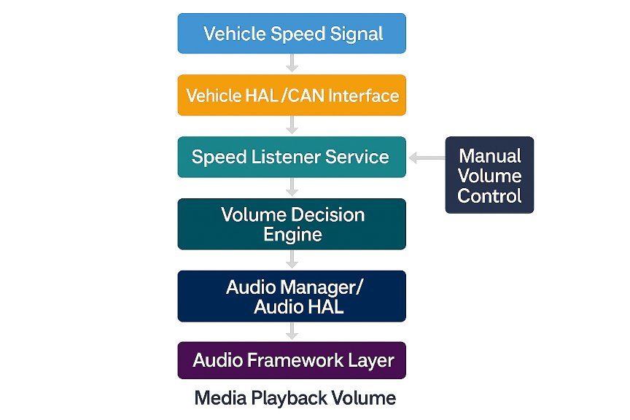

6. Use Cases
Use Case 1: Highway Driving
Description
When speed increases, the system increases media volume gradually.
Expected Result
Driver can hear audio clearly without manual adjustment.

Use Case 2: City Traffic
Description
At low speed or traffic signals, the system lowers volume.
Expected Result
Avoid unnecessarily loud audio.

Use Case 3: Manual Override
Description
Driver manually changes volume.
Expected Result
Automatic control pauses temporarily.

7. Assumptions
- Vehicle speed data is available.
- Audio APIs are accessible.
- System has permission to control media volume.

8. Constraints
- System controls only MEDIA audio stream.
- Internet connection is not required.
- System must not affect navigation or call audio.

9. Future Enhancements
- Noise-based audio adjustment
- Driver-specific profiles
- AI-based adaptive learning
- Advanced audio routing

10. Conclusion
The Speed-Based Media Volume Control System improves driver comfort and reduces distraction by automatically managing media volume according to vehicle speed. The system provides smooth, intelligent, and safe audio control suitable for modern automotive infotainment systems.

